Дата: 30.01.2023 Клас: 7-Б

Предмет: Англійська мова

Тема: Найпопулярніші види спорту в Україні.

Мета: повторити і узагальнити лексико-граматичний матеріал з теми «Спорт»; формувати навички усного мовлення; розвивати комунікативні здібності учнів; практикувати інтерактивні форми навчання. удосконалювати навички аудіювання й усного мовлення з опорою на лексико-граматичні структури; розвивати мовну здогадку; виховувати доброзичливе ставлення до співрозмовника

Вчитель: Глуговська Л.Г.

**Хід уроку**

***1.Greeting***

Good afternoon, dear children! I’m glad to see you. Are you ready to start our lesson? Let’s start.

***2. Vocabulary box***

Знайомимося з новими словами по темі. Запишіть у словник та вивчіть.

|  |
| --- |
| Competitor – учасник змагання  Indoor game – гра у приміщенні  Outdoor game – гра на свіжому повітрі  What`s the score? – Який рахунок?  2 to 5 in our favour – 5:2 на нашу користь  To kick at the goal – бити по воротах  To win the game with a score – виграти гру з рахунком  To pen the score – відкрити рахунок |

***3. Grammar***

p.103-104

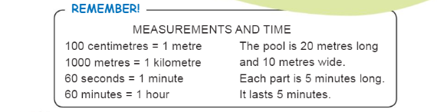

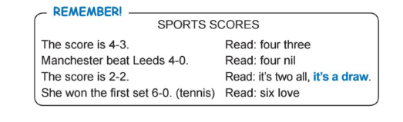

***4. Reading***

- Прочитайте і перекладіть текст усно.

The modern way of life when people have little physical activity, use cars instead of walking, watch television for many hours and work on com­puters is turning them into legless creatures. Although a lot of people are interested in staying healthy, not many people do very much about it. Only 10 per cent of adults take part in sport more then twice a week.

The majority of people life in towns and cites, where space for team sports is limited. To keep fit, most people take part in individual sports. Taking part in all of these sports is Informal and casual. Most people just want to relax. If they do aerobics or go swimming, they usually go to the sport centre, but not many people join a sport club.

Some people argue that sport is not very useful. It takes a lot of energy and time. As a result of going in for sports, people have broken legs and arms and other injuries. Besides, it makes you unhappy when you lose. A lot of people prefer to watch sports competitions rather than take part in sports. Thousands of people go to the stadiums to support their favourite teams and sportsman. The most popular spectator sports are football, hockey and figure skating. Most of the important competitions are televised and people enjoy watching sports programmes on TV.

The most popular sports in Ukraine are football and hockey, skating and skiing, track and field and swimming, tennis and basketball. It is not always easy to decide which sport to take up. The aim of all sports train­ing is to improve fitness and skills, and to develop training programmes that are both safe and effective. The important thing, however, is that any­one who is not used to exercising should not do too much at the beginning. Moreover, it is better to do a little regularly exercise are a healthier heart, stronger bones, quicker reaction times and lees susceptibility to various ill­nesses. Scientists believe that if you go in for sports on a regular basis, it could even help you to live longer.

***5. Speaking***

- Дайте відповіді на питання (усно).

* What kinds of sport are popular in Ukraine?
* Are you against or for sports?
* What are the advantages of going in for sports?
* What are the disadvantages of going in for sports?
* Is sport important to you? Why?
* Do you go in for sports? Why?

***6. Homework***

Домашнє завдання:

1. Опрацювати конспект, ознайомитись з правилом;

2. Вивчити слова.

**Надіслати виконане завдання у Вайбер/телеграм (0964124047) – Людмила Григорівна або на Human**